**Conservation of Energy: The Pendulum[1]\***

**Background**

In this lab, you will consider the motion of a simple pendulum as it swings back and forth - this will allow us to look at the conservation of mechanical energy. Mechanical energy is the name we use when we are considering both kinetic energy and potential energy.

Kinetic energy is often referred to as the *energy of motion*. Kinetic energy depends on both the mass of the object and the magnitude of the object’s velocity and can be written as



where the units of energy are Joules (J).

Potential energy takes on many forms, but is often thought of as the *energy of position*. One common form is elastic potential energy - the energy associated with things like springs and elastic. The type of potential energy that we will measure today is gravitational potential energy. Designated with a subscript *g*, the gravitation potential energy depends on the mass and position (height) of an object, as well as the acceleration due to gravity:

.

Conservation of energy is a physical law that states that energy cannot be created or destroyed. However, energy can certainly change forms - it can transfer between kinetic and potential energy - and that is the process that will be explored today.

**Goal:** The purpose of this experiment is to investigate the transformations of energy that happen during the motion of a simple pendulum and to study conservation of mechanical energy.

**Part I - Expressing Energy for the Pendulum**

Before data collection begins, we need to obtain a few variables that describe the pendulum.

* Measure the mass of the pendulum’s bob and record it here:

 = _________________ kg

* Measure the length of the pendulum, from the center of rotation to the center of the bob, and record it here:

 = __________________ m

* The rotary motion sensor can measure how fast the pendulum is rotating (swinging) and also what angle the pendulum is at for any point in time. However, it cannot directly measure the energy. That means that we need to express both the kinetic and potential energy in terms of variables to be calculated in Capstone.
  + As you learned in the section on rotational motion, the angular/rotational speed of the pendulum can be related to the linear velocity using the formula  Use this to rewrite the equation for kinetic energy in terms of 



* + Expressing the gravitational potential energy can be a bit more challenging because of the mathematics. In the figure here, *h* is the height of the pendulum above the lowest level. We don’t know *h*, though,and need to use the length of the pendulum instead.Use the image shown (and a bit of trig) to rewrite the equation for gravitational potential energy in terms of 

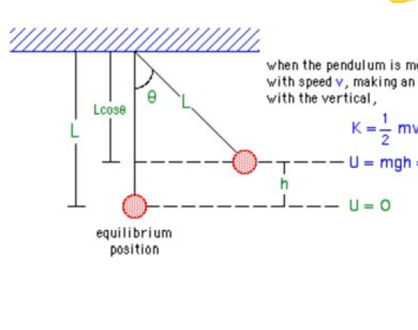

**Part II - Conservation of Energy Experiment**

Now that both kinetic and potential energy are expressed in appropriate variables that can be measured by the rotary motion sensor, you can move forward with data collection.

* Build your pendulum as shown in the figure below and attach it to the rotary motion sensor using the small silver screw. Mount the sensor and pendulum to the support rod and ensure that your system is level and securely connected.

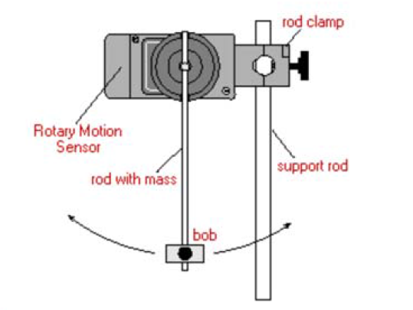

* In Capstone, add the *Rotary Motion Sensor* to the 850 Interface (use the diagram to see where the yellow and black leads should go).
* Now the energy equations need to be entered in to the Capstone program. To do this, find the left column menu and click on *Calculator.* 
  + In line 1, type “m=” and enter the numeric value for the mass of your bob, then hit enter. In the units column, type “kg” for kilograms, then hit enter.
  + In line 2, type “L=” and enter the numeric value for the length of your pendulum, then hit enter. In the units column, type “m” for meters, then hit enter.
  + In line 3, program the equation for kinetic energy that you found above . Because you’ve assigned values to  and , you can simply use those variables. When it’s time to use the angular velocity , click on the multicolored triangle at the bottom and select *“Angular Velocity”*. This will allow the program to use the data collected in these calculation. Enter  in the units column for Joules.
  + In line 4, program the equation for gravitational potential energy that you found above . Again just use the variables  and , and type “9.8” for  Click on the multicolored triangle at the bottom and select *“Angle”* from there. Enter  in the units column for Joules. Click the *Calculator* button again to hide the menu.
* With the pendulum at rest in the equilibrium position, press the ***Record*** button. Lift the pendulum about  and let it go. Collect data for about five seconds, and then press ***Stop***.

The next steps will talk you through a series of graphs that you can create and answer questions about. If your instructor requests, print or sketch the sets of graphs. If you have a good data set, *do not delete your data!* You can switch graphs to show different quantities using the same data, so the following questions can all be answered using the same set of data.

* Set up two graphs so that they are stacked vertically. On the top graph, plot kinetic energy versus time. (You should be able to find “K” by clicking *SelectMeasurement* under the *Equations/Constants* section.) Similarly, set up the bottom graph to be the angle (angular position) versus time.
  + What was the maximum angular displacement of the pendulum around its equilibrium position? Give your answer in both radians and degrees.
  + What was the maximum kinetic energy of the pendulum? Where was the pendulum whenever its kinetic energy was at its maximum?
  + What was the minimum kinetic energy of the pendulum? Where was the pendulum whenever its kinetic energy was at its minimum?
* Change the two graphs so that they show gravitational potential energy versus time on the top and angular position versus time on the bottom.
  + What was the maximum gravitational potential energy of the pendulum? Where was the pendulum whenever its gravitational potential energy was at its maximum?
  + What was the minimum gravitational potential energy of the pendulum? Where was the pendulum whenever its gravitational potential energy was at its minimum?
* Change the two graphs so that they show gravitational potential energy versus time on the top and kinetic energy versus time on the bottom.
  + How does the behavior of the potential energy compare to the behavior of the kinetic energy?

**Summary Question**

What can you conclude about energy transformations and the conservation of mechanical energy for the motion of a pendulum?

1. * Adapted from a PASCO eLab file

   Image credits: PASCO Incorporated, Roseville CA