Newton’s 2nd Law: Atwood’s Machine*

Background
In this experiment you will investigate Newton’s 2nd Law. This law states that the net (or, total) force on an object is proportional to the acceleration of the object. Or, in equation form
If we rearrange the above equation to solve for the acceleration, we see Because the acceleration depends on two variables, mass and force, you will hold one variable constant while the other is varied.

The system that you will examine is called Atwood’s Machine. Atwood’s machine consists of two unequal masses that are connected by a string (the mass of the string is negligible) over a pulley (a frictionless, massless pulley). When the masses are released, the gravitational force accelerates both masses. An image of the Atwood’s Machine is shown in Figure 1.

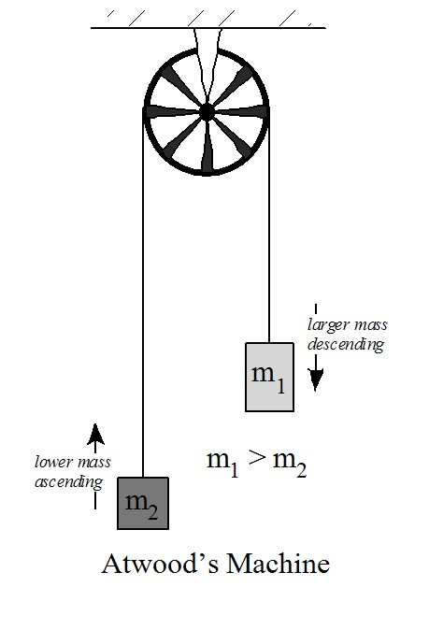
Figure 1 Atwood's Machine set up+

- Draw a free body diagram for each mass. Assume that m₁ is the more massive object. Remember to include tension and the gravitational force. Also, draw an arrow that indicates the direction that each block is accelerating. If any of the forces on the diagrams are equal, circle them.

m₁
m₂

- Next, write out Newton’s 2nd Law for each of the objects above. We’ve started the first line of each for you.

- Because the same string connects both blocks, you should see that the Tension on both blocks is equal! Also, because the blocks are moving together as a single unit, we know that the accelerations must also be equal . Use the fact that $F_{T1}= F_{T2}$ to combine the equations above and find an expression for the acceleration. Check with your instructor to confirm that you have the correct expression for acceleration.

Notice that in the equation above you have found a way to determine the acceleration of the objects based on the masses. In particular, the numerator contains the mass difference for the system (how much more massive one block is than the other), and the denominator is the total mass (the combined mass of both blocks). In the following activities, you will experiment with each of those variables.

Goal: The purpose of this experiment is to investigate how the acceleration of a system varies when the net force acting on it and the mass are varied.

Part I - Varying the Net Force
In this part of the lab, you will be changing the mass difference between the two sides. This will effectively vary the net force on the system, while keeping the total mass constant. So, if $F_{net}=ma$, F_{net} will increase and you will see how “a” will change.

- Connect two mass hangers over a pulley to a string. Be sure that they are tied securely and that the descending mass can fall the entire height but without hitting the table.

- Set up the Capstone program. Make sure that the 850 Interface is connected and then add a “Photogate with Pulley” sensor. Choose the “Table and Graph” display option.
  - Because you will need to enter the mass data, we need to set up the table so that you can add your own values. In the first column of the table, click on the “Select Measurement” button and choose “Create New→User Entered Data.” Type “Acceleration” as the label for this column. In the second column, click on the “Select Measurement” button, and this time choose “Create New→User Entered Data.” Type as the label for this column.

- Add a second graph to your display by dragging and dropping the Graph icon from the right tool bar to your display area.
  - On the first graph, use the “Select Measurement” buttons to graph velocity (linear speed) vs. time. On the second graph, plot force (from your table) vs. acceleration.

- Start with an equal amount of mass on each hanger. For example, you could add a 20g mass to one side (the 5g mass hanger makes a total of 25g). You’re going to be moving mass around, so use a number of smaller masses on the other side that total 20g. At this point, you should have a balanced system.

  - Now, unbalance the system by moving mass pieces from the ascending side to the descending side. Press the RECORD button then release the system. Press the STOP button before the descending mass reaches its lowest point.
- Use the Fit tool to find the slope of the velocity versus time line. This is the acceleration of the system. Enter that acceleration and the appropriate force (mass difference) into the table you created. Repeat this experiment at least three more times, each time transferring another piece of mass from one hanger to the other.

- As the net force increased, what happened to the acceleration? Do your results agree with Newton’s 2nd Law? Explain.

- Determine the slope of the force vs. acceleration graph and record it here. What are the units of the slope? What is the physical significance of the slope? How well does the number agree with your experiment? Explain.

Part II - Varying the Total Mass
In this part of the lab, you will keep the mass difference the same but change the total mass of the system. So, if $F_{net}=ma$, F_{net} will be constant, “m” will increase and you will see how “a” will change.

- If you have a mass imbalance of 2g, how much is the net force acting on the system? (Remember, the net force is the mass difference times gravity.)

- Edit your table so that your columns are your inputs of Acceleration and Total Mass. Similarly, edit your graphs so that you are plotting velocity vs. time and total mass (from your table) vs. acceleration.

- Start with the same mass on each hanger (make it a small mass). Now, add 2g to one hanger to imbalance the system. Press the RECORD button then release the system. Press the STOP button before the descending mass reaches its lowest point.

- Use the Fit tool to find the slope of the velocity versus time line. This is the acceleration of the system. Enter that acceleration and the appropriate total mass into the table you created. Repeat this experiment at least three more times, adding an equal amount of mass (>20 g) to both hangers so that the 2g imbalance remains but the total mass of the system increases.

- As the total mass increased, what happened to the acceleration? Do your results agree with Newton’s 2nd Law? Explain.

Summary Questions

- What happens to the acceleration of a system when the applied force (net force) increases and the mass of the system does not change?

- What happens to the acceleration of a system when the mass of the system increases but the applied force does not change?

* Adapted from a PASCO eLab file
+ Image credit: PASCO Incorporated, Roseville CA

